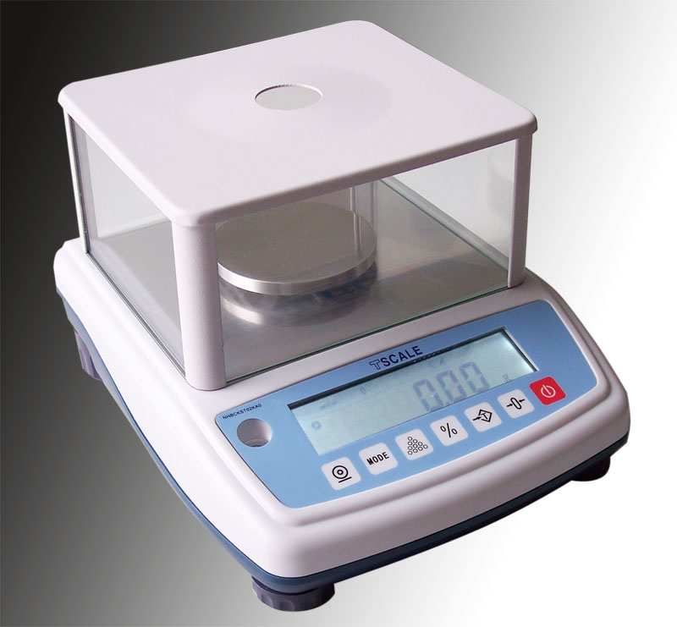
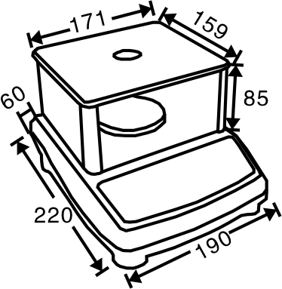
SCALE
SCALES & BALANCES
FEATURES
- Capacity from 100g to 6000g
- 16.5mm LCD display, attached LED backlight
and loading bar graph
- Rechargeable battery
- Selectable weighing unit
- Percentage weighing, counting, accumulation
- Wind shielding (capacity≤1kg)
- Standard RS-232 interface
- Optional below weighing
- Optional USB interface
TECHNICAL DATA

- External resolution…Up to 100,000
- Keyboard…….……..7 keys
- Display……….……..16.5 mm LCD
- Pan size…………....Round 80mm(100g)
Round 120mm(300~1000g)
Round 135mm(≥1500 g)
- Operate temp……...0℃～+40℃
- ADC update.……...≤1/10 second
- Rating………………AC adapter (9V/800mA)
Rechargeable battery（6V/1.2Ah）

Models and specifications to change without notice
DIMENSIONS（mm）
SPECIFICATIONS

Capacity | 100 g | 300 g | 600 g | 1000 g | 1500 g | 3000 g
NB |  | 0.01 g | 0.02 g |  | 0.05g | 0.1 g
NHB |  | 0.005 g | 0.01g |  | 0.02g | 0.05 g
NHB+ | 0.001 g |  |  | 0.01g
Pan size | Ф80mm(100g) Ф120mm(300~1000g) Ф135mm(≥1500 g)
Display | 16.5mm LCD，Attached backlight (on/off/auto selectable)
Internal counts | 1,000,000
Rating | AC adapter powered (9V/800mA)  Internal rechargeable battery（6V/1.2Ah）
Housing | ABS plastic
Gross weight | Cap.≤1000g----2.9 kg Cap.﹥1000g ----2.7kg

NB/NHB SERIES PORTABLE BALANCE

